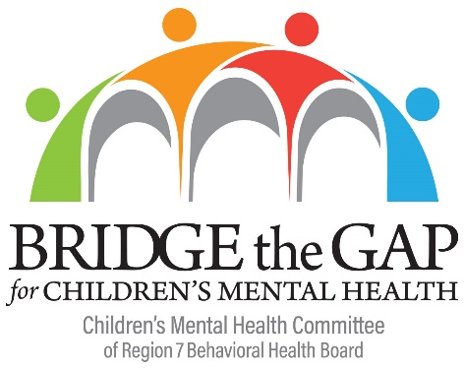
CMH Committee Meeting
AGENDA
May 18, 2018
10:00 a.m. - 11:15 a.m.
Easter Idaho Public Health Conference Room
1250 Hollipark Drive, Idaho Falls, ID

Call-in number (208) 533-3159 ▪ Passcode 8473-4386
____________________________________________________________________________
- Welcome Teriann Parker
Call for Additional Agenda Items Teriann Parker
Approval of April 13, 2018 Meeting Minutes Teriann Parker

- Children’s Mental Health Awareness Week 2018 Review Teriann Parker

- YES Program Access Model Josie Russell-Adkins

- Parent Network Laura Wallis & Amy Minzghor

- Idaho Federation of Families Steve Graci

- Announcements Teriann Parker

- Public Comment Teriann Parker

- Adjourn Teriann Parker

Next CMH Committee Meeting: To be determined

