Using Fruits and Vegetables
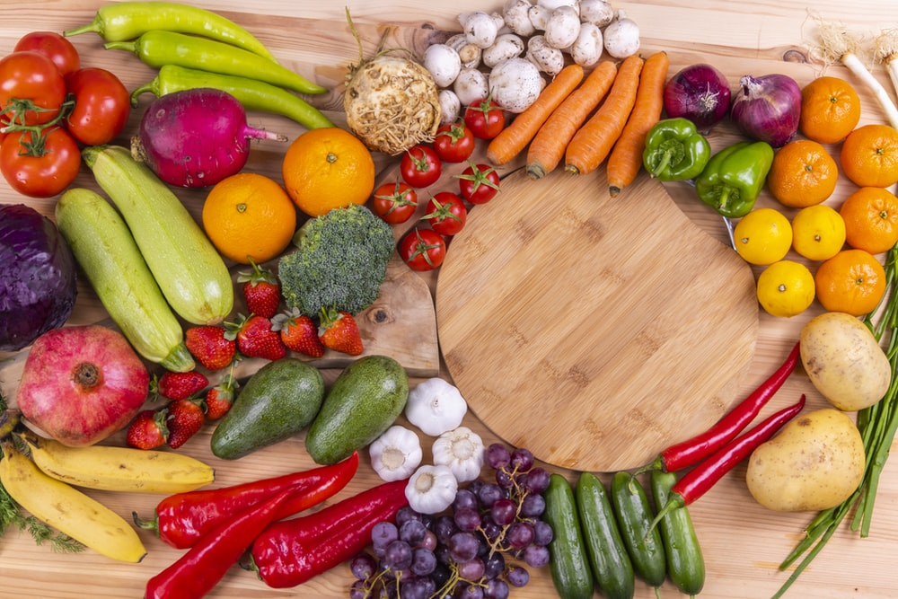
What to buy with your CVB (cash-value benefit) for Fruits and Veggies:

Any variety whole or cut fresh fruit and vegetables, including organic.

EXAMPLES:
- 5 lb. bag of potatoes
- A bunch of Bananas
- Cut watermelon
- Bagged salad greens (no dressing or toppings)
- Pre-cut, ready-to-eat fruits or vegetables
*Do Not Buy: Items from the salad bar, party trays, fruit gift baskets, decorative vegetables and fruits, packaged herbs, spices, nuts. Jarred, frozen, canned, dried. Added ingredients, non-fruit/vegetable items.

Check your mid-purchase receipt:

After you swipe your card and enter your PIN, check the mid-purchase receipt that shows what WIC will pay for. You can put back any items WIC didn’t pay for or you can purchase those separately.

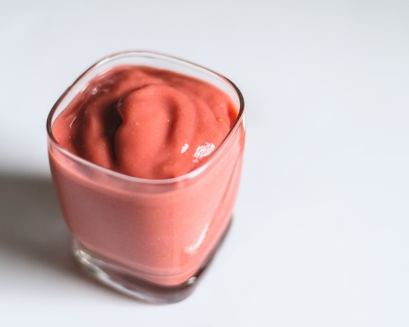
Smoothies:

Berry Green Smoothie
1 cup milk
1 cup yogurt
1/2 cup blueberries, raspberries, or strawberries
A handful of greens of your choice

https://eiph.idaho.gov/WIC/Resources/General%20Nutrition/Green%20Smoothie%20Recipes.pdf
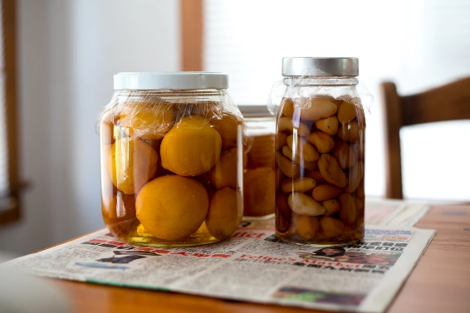

Canning:
Directions on how to can fruits and vegetables as well as important safety information:
https://nchfp.uga.edu/publications/publications_usda.html

Freezing:
Wash and dry, remove cores or seeds, then chop into bite-sized pieces. Blanch vegetables by placing cut veggies in boiling water for 2.5 minutes. Remove and run under cold water; then dry. Arrange fruits or veggies in a single layer on a baking sheet, and put into the freezer overnight or until frozen. Transfer to airtight containers or freezer bags. Enjoy within 6-12 months.
https://www.actionforhealthykids.org/wp-content/uploads/2019/09/TS_Freezing-Fresh-Fruits-and-Vegetables_v1.pdf
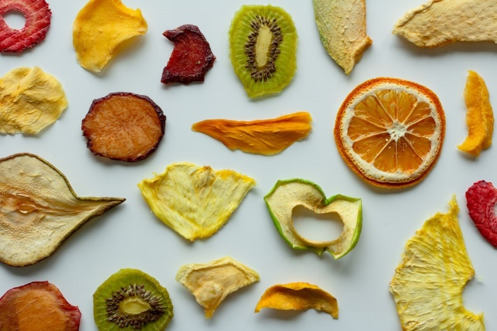
Drying:
Wash and peel ripe fruit, removing cores or pits. Small fruits like berries can be left whole. To prevent browning, dip fruits like apples in a mixture of ¼ cup orange, lemon, or pineapple juice and 2 cups water.

Slice the fruit evenly, and arrange in a single layer on a parchment-lined baking tray. Preheat the oven at the lowest setting (about 170-200 degrees Fahrenheit) and bake for 3-5 hours (depending on the water content of the fruit and the thickness of the slices.) Leave the door propped open a few inches to allow moisture to escape (CAUTION: it is not safe to leave the oven open around children.) Stir fruit every 30 minutes. When finished, the fruit should be chewy and bendable, but not sticky or wet. Remove and let stand overnight. Store in airtight containers. Enjoy as a snack or use in salads, baked goods, oatmeal, or granola.
Money Saving Tips:

Buy what’s in season: https://www.idahopreferred.com/wp-content/uploads/2014/04/IdPref_FreshCalendar.pdf

Learn how to store your produce so it lasts longer: https://extension.purdue.edu/foodlink/includes/pubs/Storing%20Fruits%20and%20Veggies.pdf

Plant your own! https://www.foodhero.org/garden-tip-sheets

Other Things to Try:

- Dip fruits and vegetables in salsa, hummus, nut butter, or homemade yogurt dip!
- A taste test using fruits and vegetables from all colors of the rainbow or using different letters of the alphabet.
- Learn about different fruits and veggies with fun coloring sheets. https://www.foodhero.org/coloring-sheets

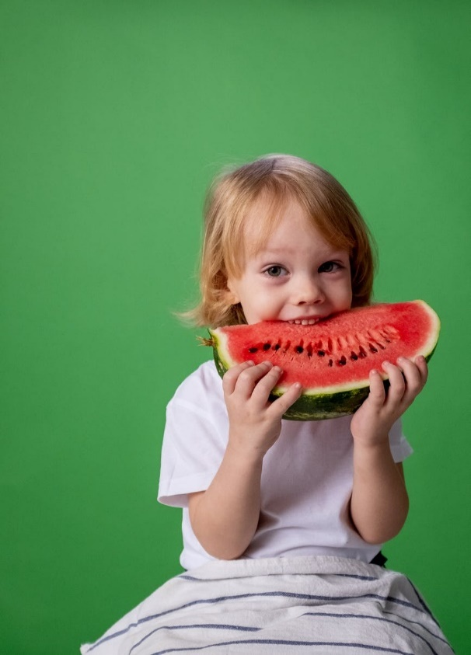

For More Recipes:
https://fruitsandveggies.org/recipes/
https://www.foodhero.org/recipes/healthy-recipes
https://www.chopchopfamily.org/recipes/
https://recipes.doctoryum.org/en/recipes

This institution is an equal opportunity provider. 5/21

