August 14, 2025
Region 7 Behavioral Health Board
Martha Tanner Memorial Grant Committee
Dear Committee Members,
On behalf of FYIdaho, I am honored to submit our application for the Martha Tanner Memorial Grant. We deeply admire the legacy of Martha and John Tanner and their lifelong commitment to mental health advocacy and service. This proposal reflects our dedication to continuing that legacy by ensuring families and youth in Eastern Idaho have access to the advocacy, education, and navigation services they need to support treatment and recovery.
Established in 1999, FYIdaho is a family-run nonprofit organization that provides free peer-based support to families navigating the mental health system. The $1,000 grant will allow us to expand access to these critical services across Region 7, ensuring families have the resources, knowledge, and support to promote recovery and resilience.
We thank you for the opportunity to apply and for your continued efforts to strengthen mental health resources in our community. Please do not hesitate to reach out if additional information is needed.
With gratitude,
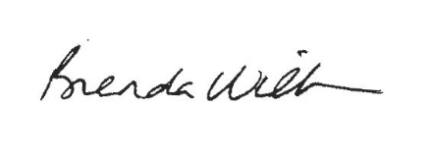
Brenda Willson
FYIdaho
bwillson@fyidaho.org

